***“PROJECT REPORT”***

**GROUP MEMBERS**

1) MUHAMMAD HASSAM(02-131192-019)

2) MUSTAFA HUSSAIN(02-131192-004)

3) MUHAMMAD USMAN KHAN (02-131192-061)

**TABLE OF CONTENT:**

1. Abstract
2. Introduction
3. Solution
4. Conclusion
5. Tools

**ABSTRACT:**

We the group members jointly collaborated each and every task of project with help and support of one another. In the project we made a **WEBSITE on SUBLIME**, and an **MS ACCESS** database and. In the last we made a **POWERPOINT** **PRESENTATIO**N on the given topic i.e. HOSPITAL. All the work is done in the sequence, all steps and procedure are tried to be taken in consideration which we are taught during our lectures. We have divided our report in 3 parts.

**INTRODUCTION:**

Our project is to make a website, database, presentation on a hospital. We did our project in a group. Our group leader is Muhammad Hassam. We as a group did all the work of the project together and uploaded our project on GitHub in this sequence that Hassam uploaded website, Usman uploaded Microsoft access work and report and Mustafa uploaded presentation.

**SOLUTION:**

**WEBSITE:**

Before starting our website project we made a layout to what to do in our project i.e. we must use navigation, padding, margin, and all other necessary thing must be in our consideration. Here we use CSS, Html and Bootstrap. Which make our Website responsive and user friendly.

Here we will discuss the things necessary to mention in report, we use a navigation bar along with a background color, with Home, About, Services and Contact us section, when clicked on it also placed a link on it so to differentiate from a button. Moreover a div is also used, div is basically a container which we used to specify a certain region in our webpage, and containing different sections, all thing are written under body tag so to display it on a webpage. Inline, Internal, External CSS is also used where it was necessary. We tried to give Flavors of all necessary things. Multiple ID’s and CLASSES are also used here. And try to make user friendly Website.

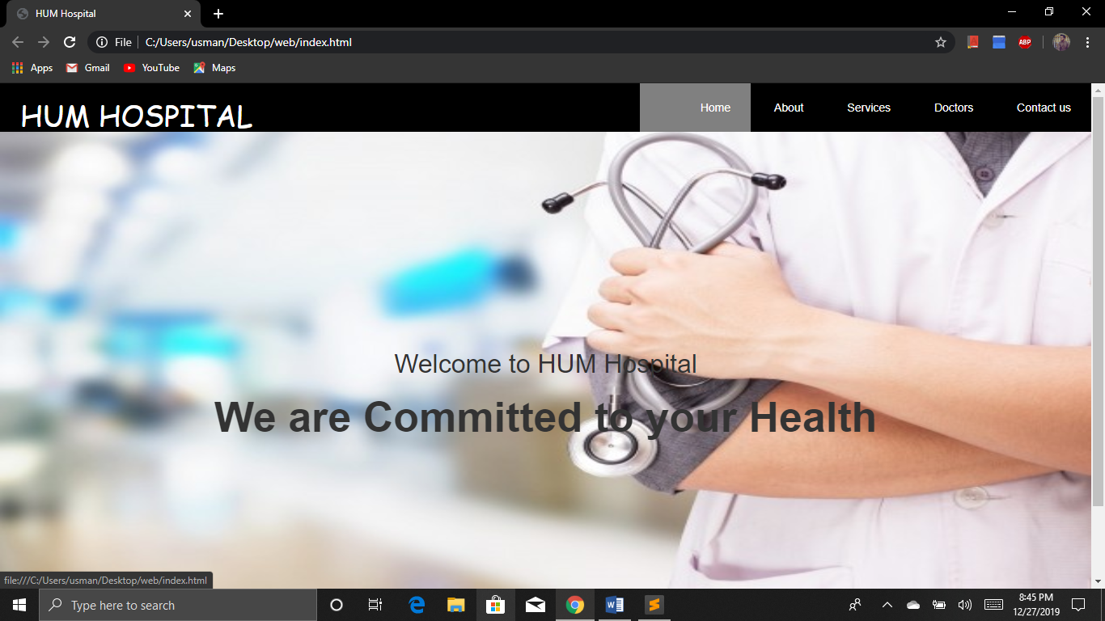

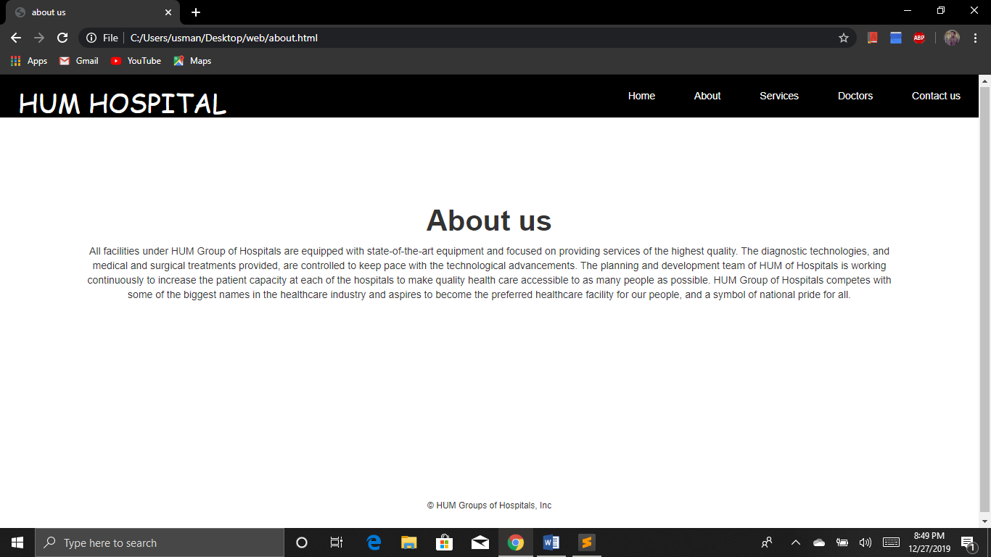

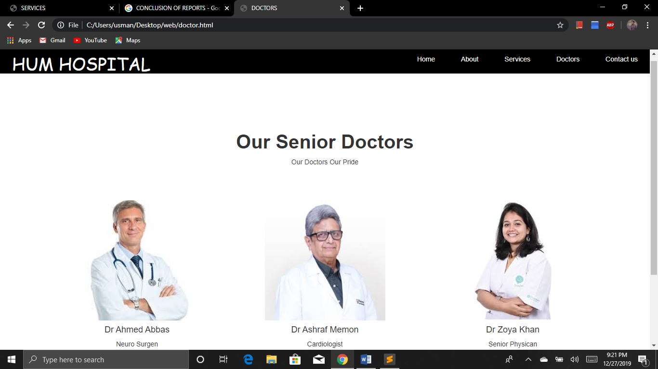

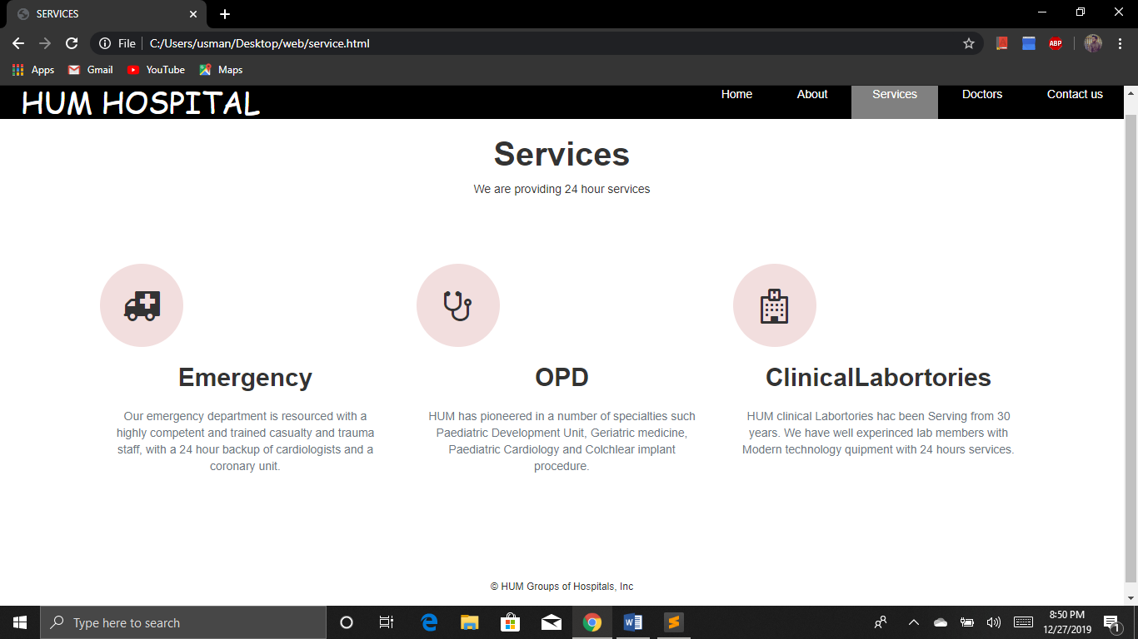

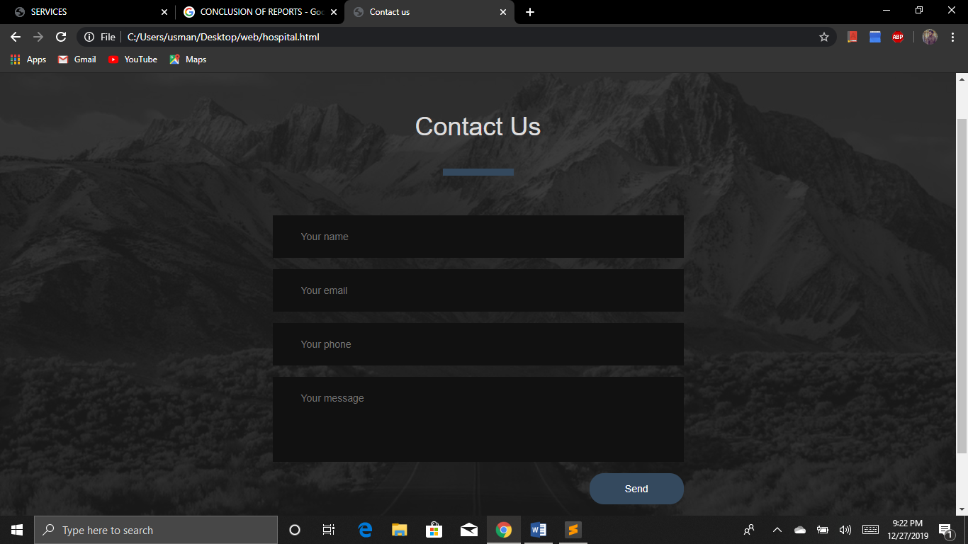

**MS ACCES DATABASE:**

In Microsoft access database we first go through all necessary thing which we need to maintain our data. We made a pencil record of desired thing.

In the database we made two tables one for doctor record and the other for patients.

We also made a query to show a relationship, so to get better view and better idea of data and instructions.

Reports and forums are also made to have better view of data.

Some screenshots of MS access work are attested below.

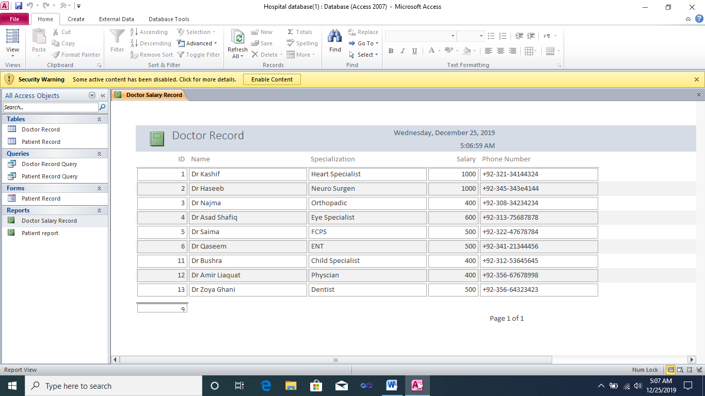

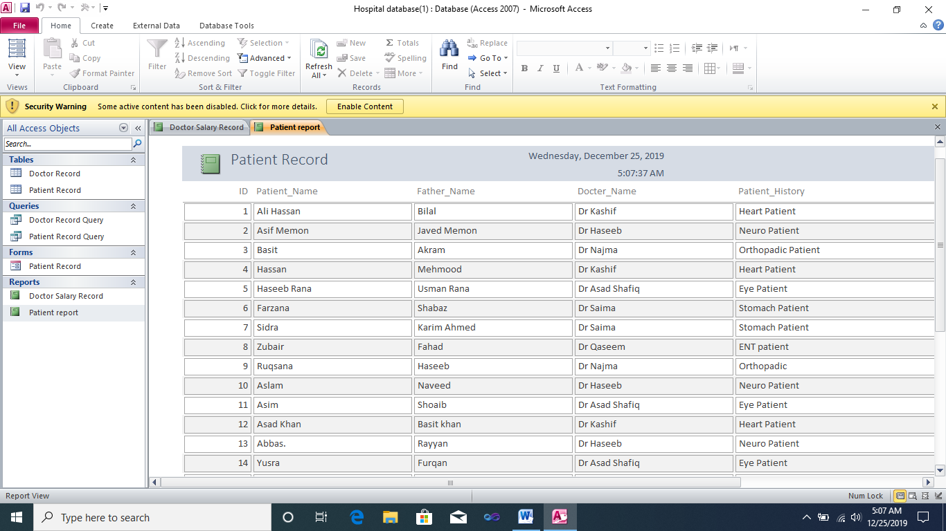

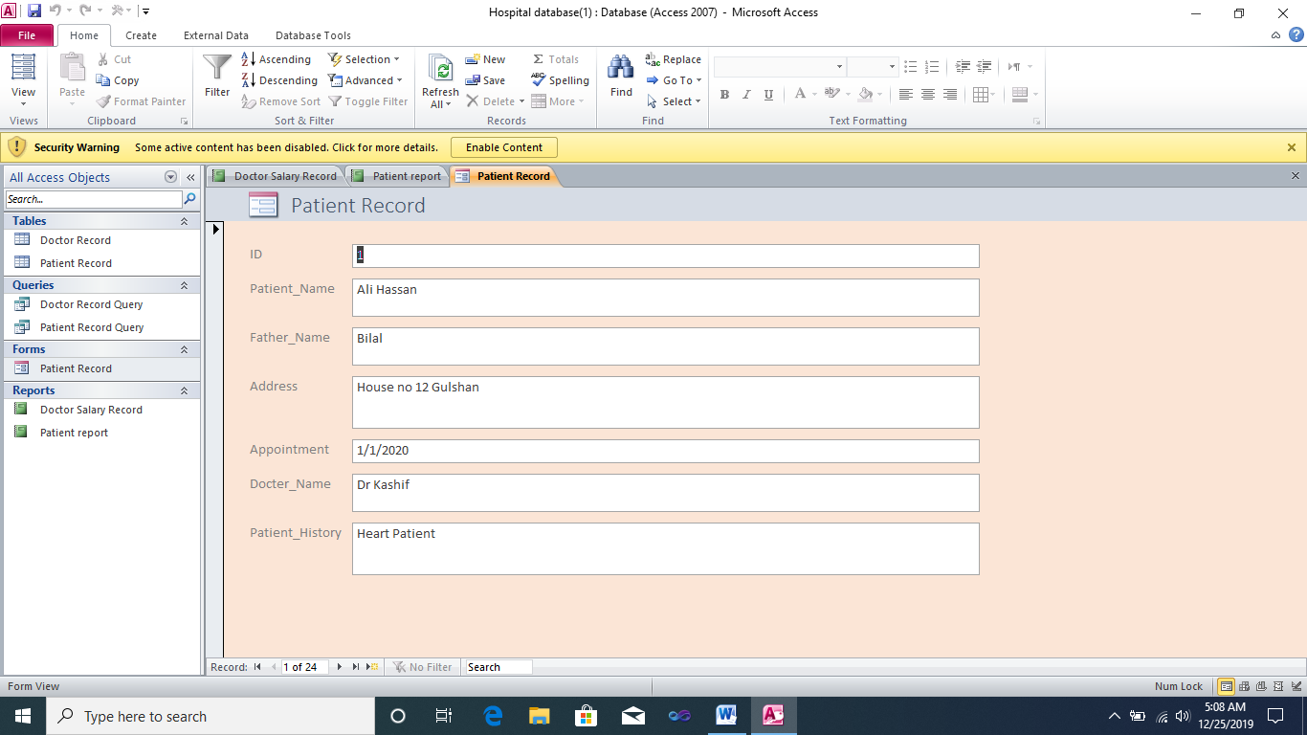

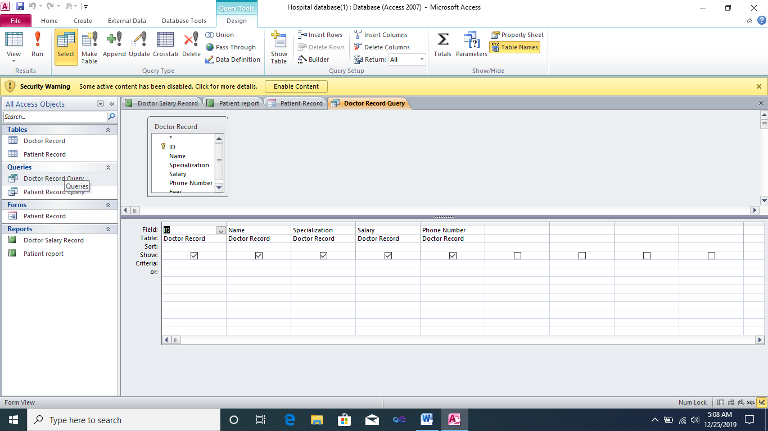

**MS POWERPOINT:**

We also made our presentation on powerpoint. In this presentation we presented our hospital’s facilities, departments, detail about our doctor, our nursing staff , our hospital’s atmosphere and environment, our medical college, blood bank ,our mission. Some screenshot of our presentation our attested below.

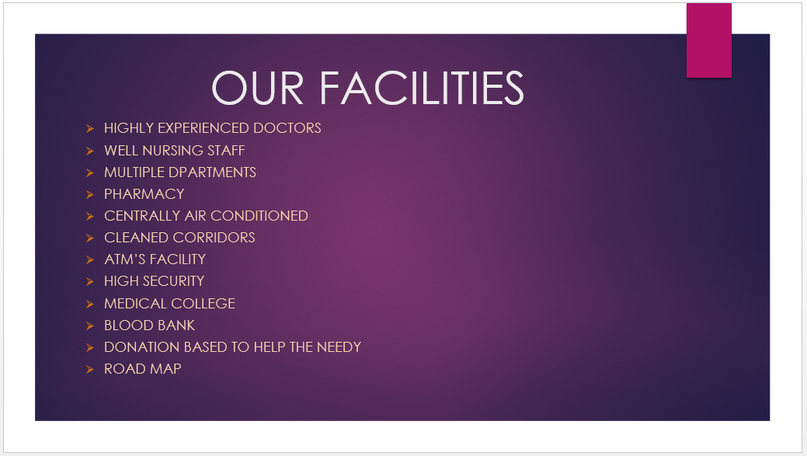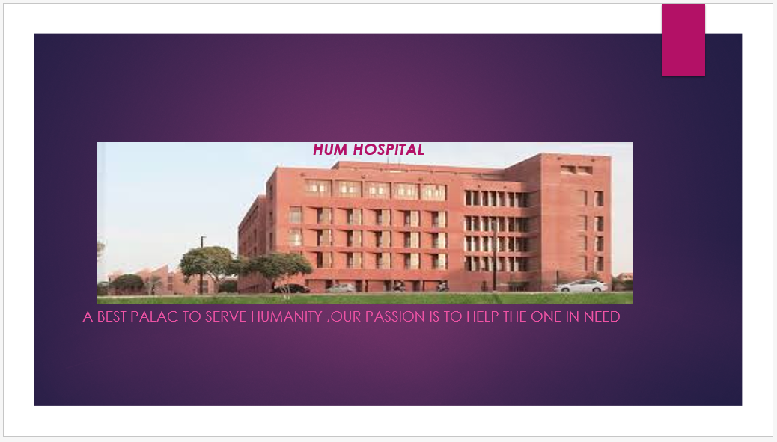

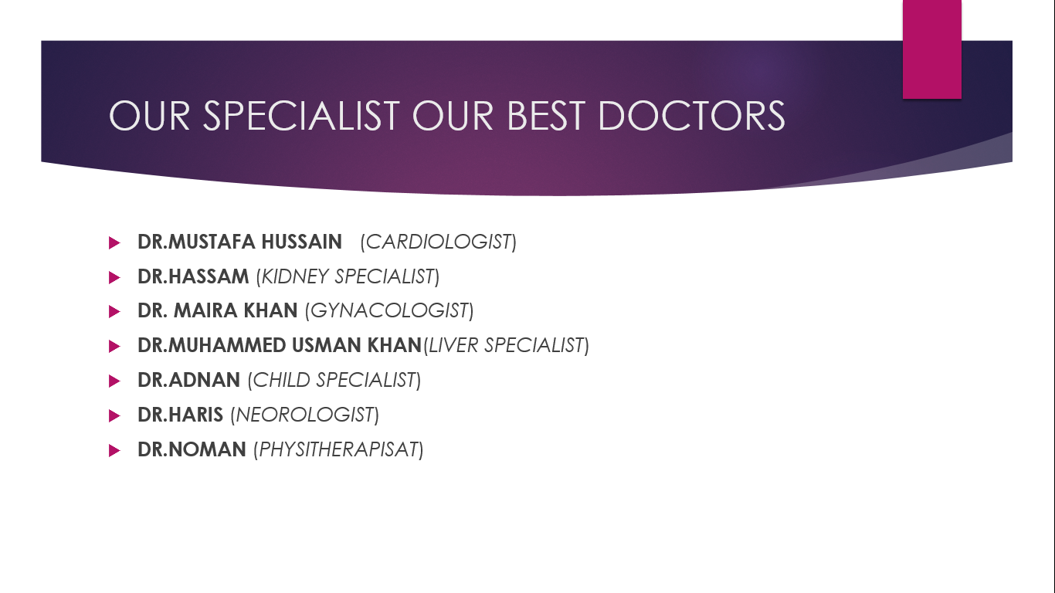

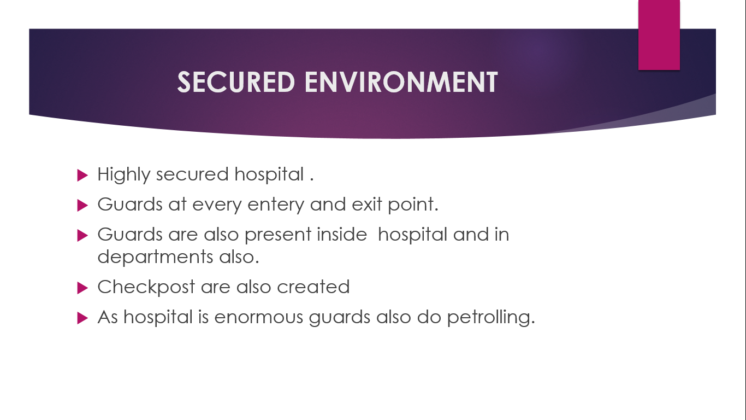

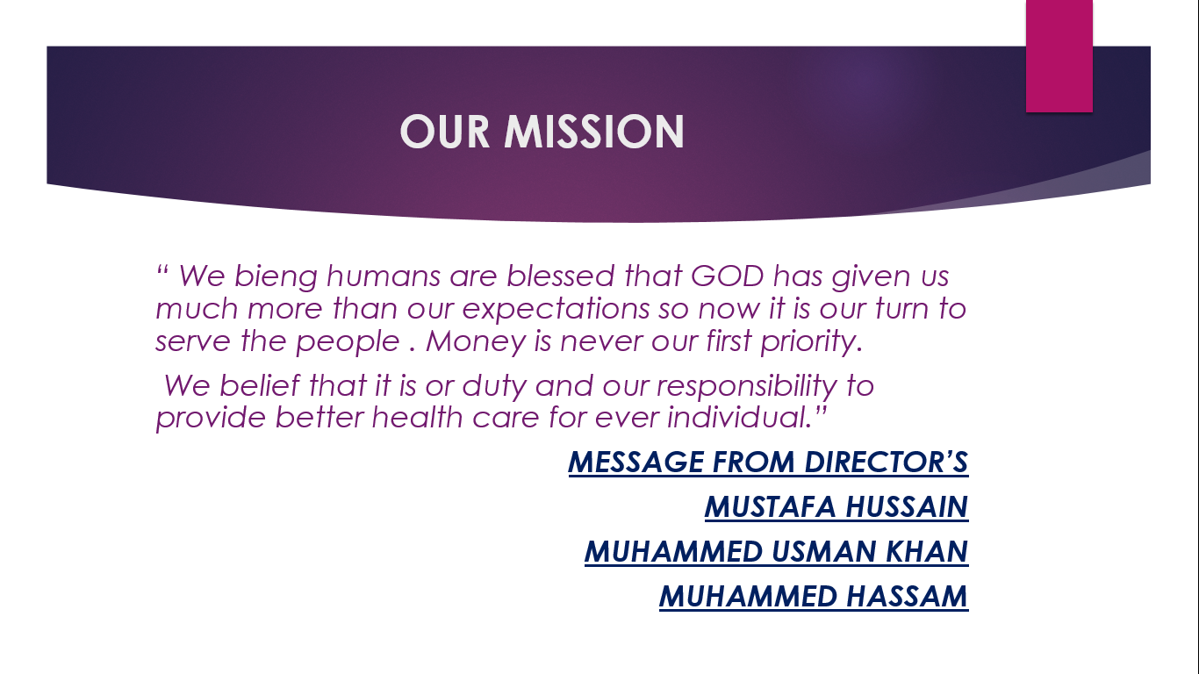

**TOOLS:**

1. Sublime(Website).
2. Microsoft Access(Database).
3. Microsoft PowerPoint(Presentation).
4. Microsoft Word (Documentation)
5. GitHub.

**CONCLUSION:**

In these project we made Website for private hospital by using html, css and bootstrap to make our website responsive and friendly user on Sublime Editor. We also made a Database for hospital to help them in maintaining data by using MS Access and lastly we made a presentation of Hospital in which we put the information of our hospital by using PowerPoint. This project improves our concept about websites making and managing database in Microsoft access and also making presentation on PowerPoint.

**“THANKYOU”**